Weekly Geography Assignment
Name: _________________________________________Period: ______ Date: _____________
Instructions: On a weekly basis, geography students are required to complete this assignment. Students need to find an article from the week the assignment is due. Students can use the internet or a national newspaper. The article should describe an incident in a foreign country and how it affects the United States. After reading the article, students need to complete this worksheet. Answers need to be handwritten and legible. The assignment is worth a maximum of 20 points on the day it is due. Work turned in prior to the next weekly assignment will be worth only a maximum of 16 points. Assignments cannot be made up after the next assignment is due. Assignments that appear to be copied or plagiarized from other students will not be given credit.

1. Name of the Article and Source: ________________________________________________________
_____________________________________________________________________________________
2. Put a star on the map below indicating the location of the country where the news occurred.
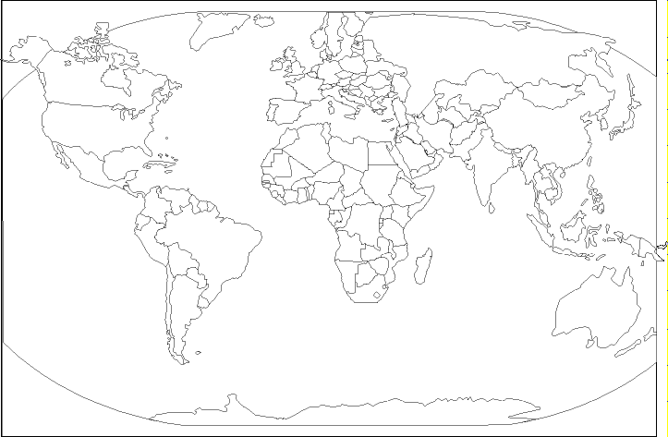
3. Name the country and list three other countries found in the region around the country you identified on the map.
a. ___________________________________________________
b. ___________________________________________________
c. ___________________________________________________
d. ___________________________________________________
4. In the space provided, give a brief summary of the article: _____________________________________________________________________________________
_____________________________________________________________________________________
______________________________________________________________________________________________________________________________________________________________________________________________________________________________________________________________________________________________________________________________________________________________________________________________________________________________________________________________________________________________________________________________________________________________________________________________________________________________________________________________________________________________________________________________________________________________________________________________________________________________________________________________________________________________________________________________________________________________________________________________________________________________________________________________________________________________________________________________________________________________________________________________________________________________________

5. In the space provided, describe how the events in the article impact you or the United States:
____________________________________________________________________________________________________________________________________________________________________________________________________________________________________________________________________________________________________________________________________________________________________________________________________________________________________________________________________________________________________________________________________________________________________________________________________________________________________________________________________________________________________________________________________________________________________________________________________________________________________________________________________________________________________________________________________________________________________________________________________________________________________________________________

